附件2
酒店位置及交通方式

1、会议酒店
名称：深圳君悦酒店
地址：深圳市罗湖区宝安南路1881号，毗邻万象城购物中心。
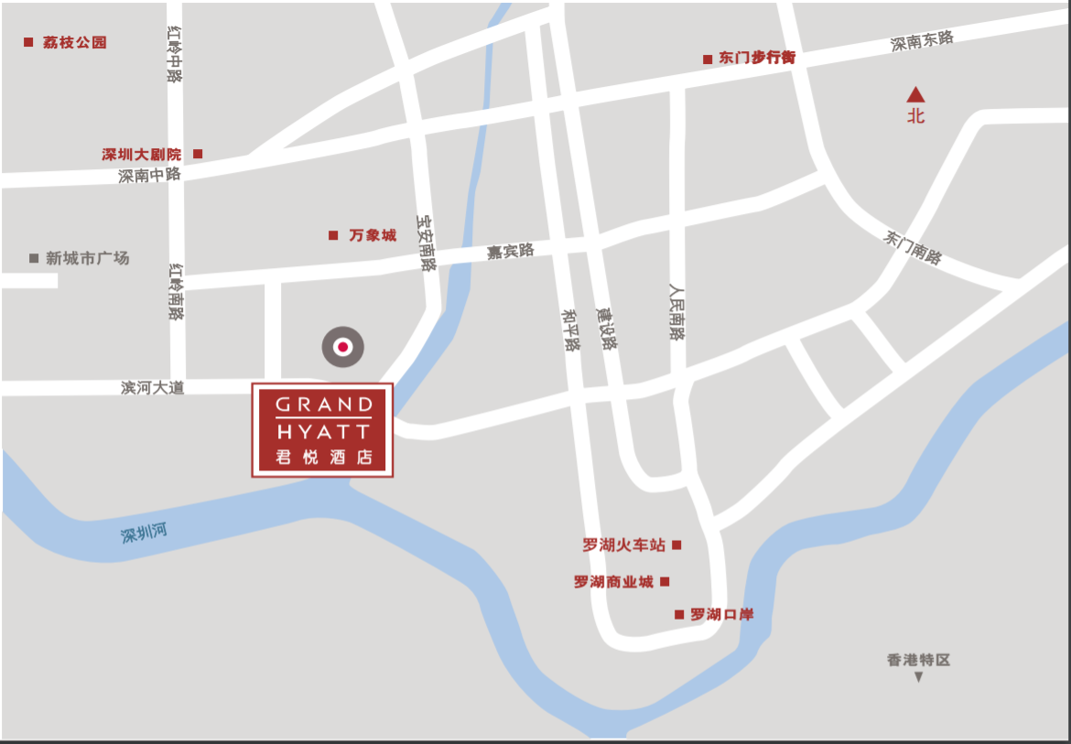
2、交通
（1）深圳宝安国际机场-深圳君悦酒店
车程39公里，预计用时49分钟。搭乘地铁11号线（福田方向）至车公庙站，换乘地铁1号线（罗湖方向），大剧院站下车（F口）。
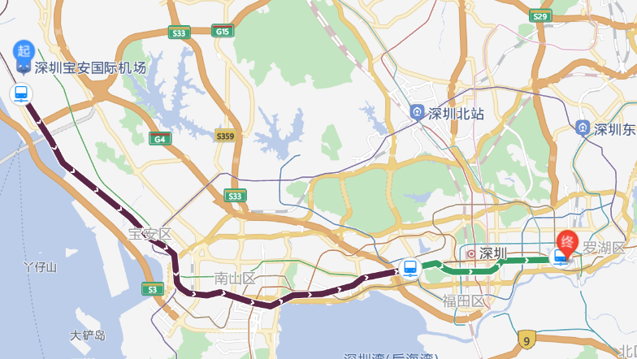
（2）深圳北站-深圳君悦酒店
车程20公里，预计用时36分钟。搭乘地铁6号线（科学馆方向）至银湖站，换乘地铁9号线（文锦方向），鹿丹村站下车（C口）。
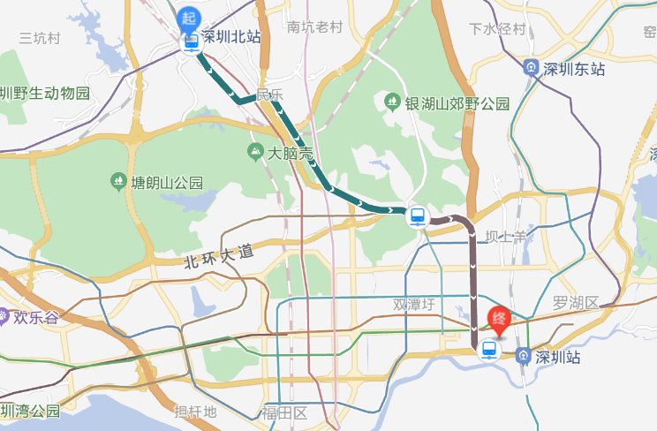
（3）深圳站-深圳君悦酒店
车程3.8公里，预计用时12分钟。步行至地铁人民南站（A1口），搭乘9号线（前湾方向），鹿丹村站下车（C口）；步行至公交渔民村站，搭乘73路/18路/321路，金威大厦站下车。
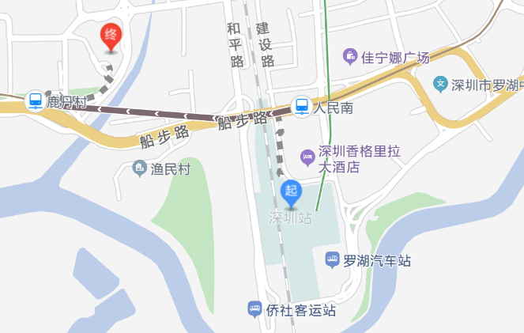
3、住宿
宝轩酒店住宿可统一安排，请于9月13日前通过报名预订。
选择君悦酒店住宿，请于9月12日前通过链接（https://www.hyatt.com/zh-CN/group-booking/SHEGH/G-GD26）自行预订，预订时需提供信用卡信息做担保，提前7天可免费取消。
房间数量有限，请提早预订。
酒店名称 | 地址 | 交通 | 标准大床房（含单早）  标准双床房（含双早）  价格（间/天）
宝轩酒店 | 罗湖区嘉宾路4055号城市天地广场裙楼 | 距离会议酒店步行约400米 | 400元（豪华房型）
君悦酒店 | 罗湖区宝安南路1881号 | 会议所在酒店 | 800元
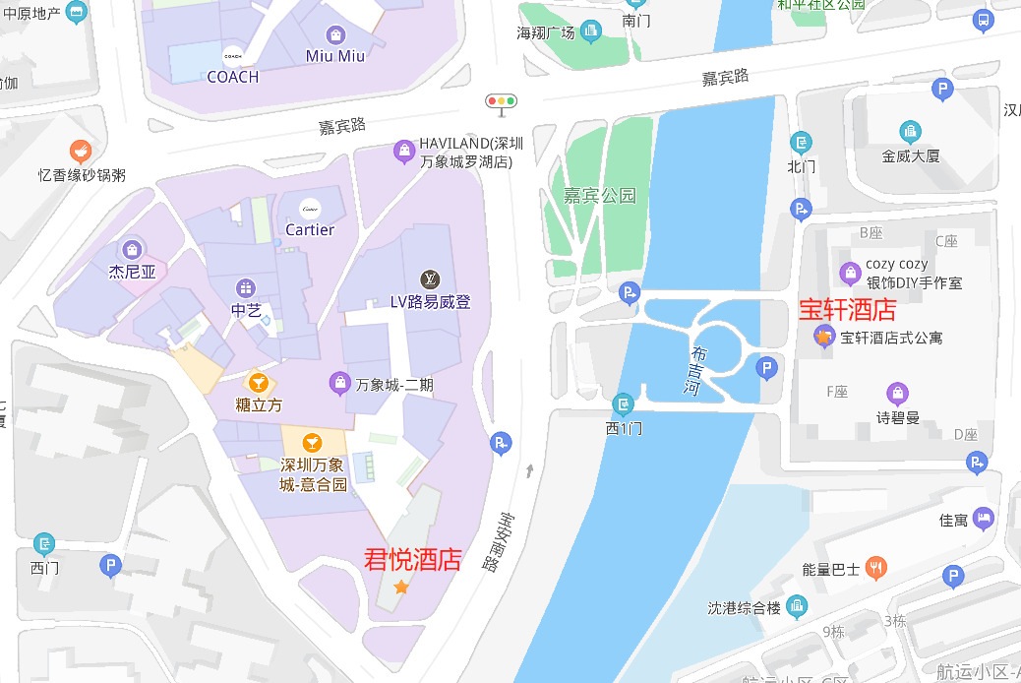

Attachment 2
Hotel Location and Transportation

1 Conference Hotel
Name: Grand Hyatt Shenzhen
Address: 1881 Baoan Nan Road, Luohu District (adjacent to the Mixc)
2 Transportation
(1) Shenzhen Baoan International Airport - Grand Hyatt Shenzhen
39 km drive, estimated to take 49 min. Take Metro Line 11 (toward Futian) to Chegongmiao Station, transfer to Metro Line 1 (toward Luohu), and get off at Grand Theater Station (Exit F).
(2) Shenzhen North Railway Station - Grand Hyatt Shenzhen
20 km drive, estimated to take 36 min. Take Metro Line 6 (toward Science Museum) to Yinhu Station, transfer to Metro Line 9 (toward Wenjin), and get off at Ludancun Station (Exit C).
(3) Luohu Railway Station - Grand Hyatt Shenzhen
3.8 km drive, estimated to take 12 min. Walk to Renmin South Station (enter A1) and take Metro Line 9 (toward Qianwan), then get off at Ludancun Station (Exit C); or walk to Yumincun Bus Station and take Line 73/18/321, then get off at Jinwei Building Station.
3 Accommodation
Accommodation is at your own expenses. Number of rooms is limited, please book as early as possible.
(1) If you need accommodation at Bauhinia Hotel during the conference, please fill in the registration form and submit before Sep 13.
(2) If you need accommodation at Grand Hyatt, please book through the link (https://www.hyatt.com/zh-CN/group-booking/SHEGH/G-GD26) before Sep 12, and credit card information is required for guarantee when booking (free cancellation: 7 days in advance).
Hotel | Address | Transportation | King Room (including 1 breakfast)  Twin Room (including 2 breakfast)
Bauhinia Hotel | City Square Podium, 4055 Jiabin Road, Luohu District | 400 m walk to the conference hotel | 400 CNY/night (deluxe)
Grand Hyatt | 1881 Baoan Nan Road, Luohu District | the conference hotel | 800 CNY/night

